# Meridional Heat Transport Tutorial Tasks

## Task 1:

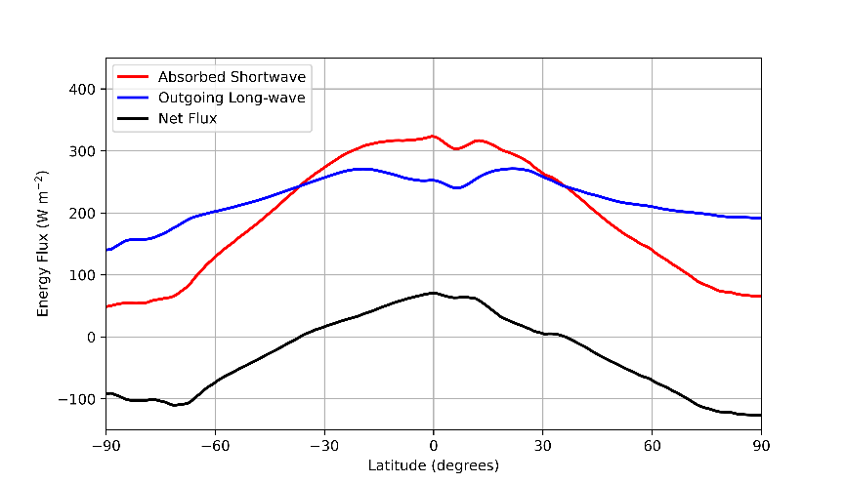

Fig 1: Original figure reproduced (annual mean 2001).

The figure is recreated after understanding and running the code.

## Task 2:

Fig 2: Energy balance during Austral summer 2000-2001.

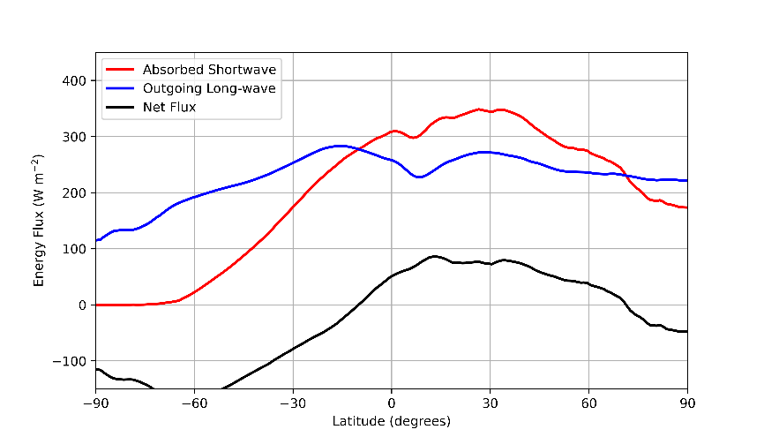

Fig 3: Energy balance during Austral winter 2001.

There is a clear peak at lower latitudes in the Austral summer and at higher latitudes in Austral winter. This represents the orientation w.r.t the sun, that is, the southern hemisphere getting more sun than northern hemisphere in southern hemisphere summer and vice versa even though averaged over the whole year the equator gets the most sun.

## Task 4:

The meridional heat transport data was found by passing net flux data for the year 2001 to the “inferred_heat_transport” function, this was then plotted against latitude.

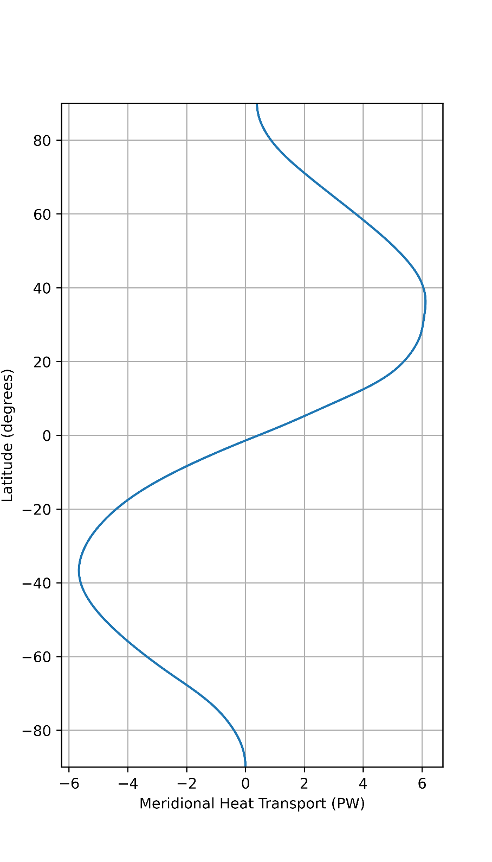

Fig 4: Meridional heat transport annual mean 2001.

## Task 5:

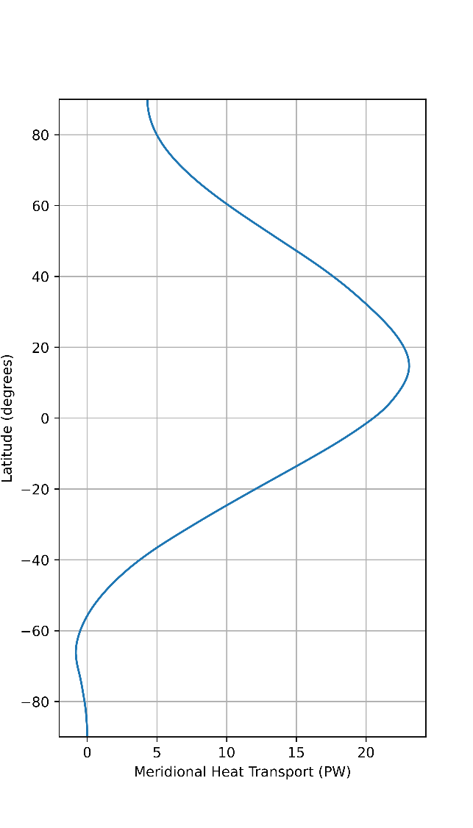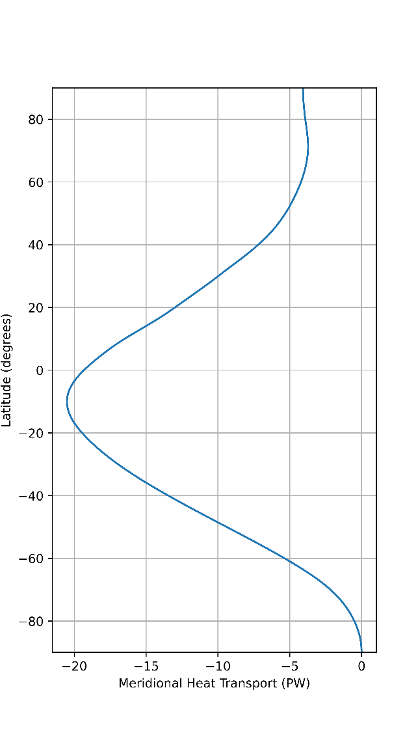

Fig 5: Meridional heat transport mean Austral summer 2000-2001.

Fig 6: Meridional heat transport mean Austral winter 2001.

In the austral summer the southern hemisphere is warmed the most and the northern hemisphere is warmed the least so there is the largest net energy imbalance just above the equator. In the austral winter the reverse occurs.